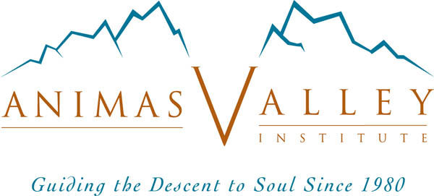

Soulcraft Apprenticeship and Initiation Program Application

Name: _________________________________________ Date of application: ______________
Address: ____________________________________________ Date of Birth: ______________
City: ________________________ State: _____ Country: ________ Postal Code: ____________
Phones: _________________________________ email: _________________________________
Occupation: ______________________________________________________________________

Eligibility Requirements:
(1) At least one prior vision fast (need not have been with Animas)
(2) At least one prior Animas core program (i.e., an Animas Quest, Soulcraft Intensive, Soulcraft Journey, or Advanced Intensive)

List all previous Animas programs you have attended (add rows as needed):

Program Year Guides
1)
2)
3)

Check all tracks in which you plan to enroll (see SAIP brochure for descriptions)

___ Soulcentric Vision Fast Guiding ___ Soulcraft Leadership
___ Soul-Oriented Professional Development

Please also respond to the following questions (please limit your response to no more than 10 pages – we’ll ask if we need more info!):

- An introduction. Tell us something about yourself — even if we already know you.
- If accepted, what would be your purpose in enrolling in SAIP? In what setting(s) do you see yourself using the skills you would develop through SAIP?
- Tell us about your most recent vision fast: Who went out? What did you learn? Who returned? What did you bring back for your people? Who are your people?
- Briefly list your previous soul-oriented and nature-based study, training, and experience, especially those that combine both aspects. Please include your previous experience with rites of passage, other ritual, vision fasts, wilderness travel, first-aid, search and rescue, depth psychology, ecopsychology, psychotherapy (as client as well as therapist), and spiritual disciplines.
- Please describe your premises and beliefs about soulcraft.
- What is your understanding of underworld guiding and of soul-initiation guiding? Include your definition of these phrases.
- Please briefly describe what you know about your "soul work" or the gift that only you can offer the world. Please address both what you know about your preferred delivery systems (e.g., teaching, healing, managing, designing, writing, guiding, etc.) AND (more importantly) what you know about WHAT you are delivering (i.e., your soul images, symbols, story, motifs, qualities, truths, mysteries, archetypes, etc.) as you have discovered through visions, numinous encounters, revelations, dreams, conversations with nature, etc.
- Please describe one or more numinous experiences that reveal that you have been called by Mystery to serve your people specifically as a nature-based soul-initiation guide.
- What is your assessment of your current state of wholeness (your degree of cultivation of each of the four facets of your Self)? Include all four facets, but please be brief!
- To what extent are you able to quickly return to wholeness when you (your ego) are hijacked by any of your subpersonalities? Please give brief examples of times and conditions in which you are able to do this and those in which it is difficult.
- SAIP is an extremely challenging initiatory and apprenticeship experience that often upends the applecart of a trainee’s current life. What tells you that you are psychologically and spiritually prepared for the risks and rigors of this training?
- Briefly describe your relationships with your parents and siblings.
- What do you know about the pattern of your romantic relationships? Does your current relationship, if any, fit with that pattern?
- What are your areas of special interest within soulcraft and underworld guiding?
- Please share any ideas you already have about how you would like to proceed with your SAIP program.

Please email your completed application to soulcraft@animas.org

Submission of this form acknowledges I have read and accept Animas Valley Institute’s Policies and Procedures - http://www.animas.org/policy/policies-procedures

Please also submit your non-refundable $50.00 application fee on our website, or mail a check to:
SAIP
Animas Valley Institute
P.O. Box 1020
Durango, CO 81302

