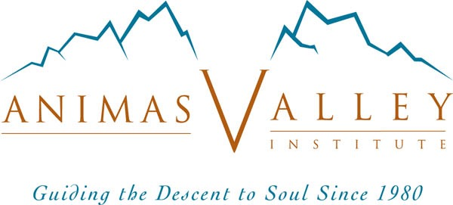

The Wild Mind Training Program (WMTP) Application

Name: __________________________________________________ Date of application: ___________
Address: _______________________________________________ Date of Birth: _____________
City: ________________________ State: _____ Country: _____ Postal Code: ___________
Phones: _________________________________ email: ____________________________
Occupation: __________________________________________________________________

Eligibility Requirements to Apply to the WMTP.
To be eligible for the Wild Mind Training Program you must already be a professional human development guide (PHDG) or an advanced student or trainee in a human development graduate school or training program. PHDGs work in fields such as psychotherapy, psychiatry, clinical psychology, professional counseling, ministry, life coaching, ecotherapy, rites of passage, education, and certain realms of mentoring and outdoor education. In most cases, we would expect you to be professionally licensed, certified, or eligible for certification if your discipline and state require it.

Applicants must complete two Animas programs prior to applying to the WMTP.

1) Wild Mind Intensive and one (1) of the following programs:
A) Any Animas Quest
B) Yearlong Soulcraft Immersion

or

2) Wild Mind Intensive and two (2) of the following programs:
A) Coming Home to an Animate World
B) Soulcraft Intensive
C) Soulcraft Journey
D) Deep Imagination Intensive
E) Soulcentric Dreamwork Intensive
F) Sweet Darkness Intensive

Recommended Programs Before Applying (Not Required):
Applicants who have completed the following Animas programs prior to applying will have stronger applications, other things being equal:

1) Council and Mirroring Intensive
2) Wild Mind Mirroring Training
3) Soulcentric Developmental Wheel Intensive (aka Nature and the Human Soul Intensive)

We also ask that you read Wild Mind before applying to the WMTP.
Please note if you have taken the following programs and, if so, dates and guides:

Prerequisite Programs (Y/N) Year Guides
- Wild Mind Intensive
And One of the Following
  - Animas Quest
  - Yearlong Soulcraft Immersion

or

- Wild Mind Intensive
And two of the following:
  - Coming Home to an Animate World
  - Soulcraft Intensive (or Advanced SCI)
  - Soulcraft Journey
  - Deep Imagination Intensive
  - Soulcentric Dreamwork Intensive
  - Sweet Darkness Intensive

Recommended Programs (Y/N) Year Guides
1) Council & Mirroring Intensive

2) Wild Mind Mirroring Training

3) SDW Intensive (Nature & the Human Soul)

Please list all previous Animas programs you have attended not listed above:

Program Year Guides
1)
2)
3)
4)
5)
6)
7)

Please also include a letter with the following parts:

- An introduction. Tell us something about yourself.

- Please describe your Professional Human Development Guide Training:
  - Please list and describe your formal academic training (if it applies)
  - Please list and describe your professional trainings (if they apply)
  - Please list and describe additional trainings and/or certificates:
  - Please list and describe your additional experience as a facilitator of human development
  - Please list any professional and or legal issues you may have had in relation to your practice as a PHDG (e.g., dropping out or being dismissed from a training program; ethics complaints; lawsuits; rejected certification applications)

- Please list your current delivery system (if you have one) in a professional human development guiding role.

- If accepted, what would be your purpose in enrolling in the Wild Mind Training Program? In what setting(s) do you see yourself using the skills you would develop through these trainings?

- List, briefly, your previous holistic, healing, and nature-based study, training, and experience, especially those that combine holistic, healing, and nature-based aspects. Please include your previous experience with ecotherapy, ecopsychology, depth psychology, psychotherapy, and rites of passage, other ritual, and vision fasts.

- Please describe your premises and beliefs about Wholing and Self-healing.

- What is your assessment of your current state of Wholeness (your degree of cultivation of each of the four facets of your Self)? What is your weakest facet? Where are you still likely to be acting from a subpersonality?

- To what extent are you able to quickly return to wholeness when you (your ego) are hijacked by any of your subpersonalities? Please give brief examples of times and conditions in which you can do this and those in which it is difficult.

Please email your complete application to soulcraft@animas.org and wmtp@animas.org and submit your $50 application fee using one of the following methods:

- Use the payment link under the “participants” tab on our homepage
- Via PayPal, sending the payment to animasoperations@animas.org

With either payment method, please note it is for the Wild Mind Training Program application fee.

Thank you!

Submission of this form acknowledges I have read and accept Animas Valley Institute’s Policies and Procedures - http://www.animas.org/policy/policies-procedures

