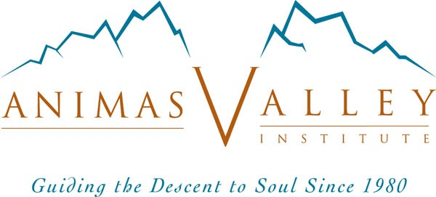

The Wild Mind Training Program (WMTP) Application

Name: _________________________________________ Date of application: ___________
Address: ____________________________________________ Date of Birth: ___________
City: ________________________ State: _____ Country: _____ Postal Code: ___________
Phones: _________________________________ email: ____________________________
Occupation: __________________________________________________________________

Eligibility Requirements to Apply to the WMTP.
To be eligible for the Wild Mind Training Program you must already be a professional human development guide (PHDG) or an advanced student or trainee in a human development graduate school or training program. PHDGs work in fields such as psychotherapy, psychiatry, clinical psychology, professional counseling, ministry, life coaching, ecotherapy, rites of passage, education, and certain realms of mentoring and outdoor education. In most cases, we would expect you to be professionally licensed, certified, or eligible for certification if your discipline and state require.

Applicants must complete two Animas programs prior to applying to the WMTP.

1) Wild Mind Intensive and one (1) of the following programs:
A) Any Animas Quest
B) Year Long Soulcraft Intensive

or

2) Wild Mind Intensive and two (2) of the following programs:
A) Coming Home to an Animate World
B) Romancing the World
C) Soulcraft Intensive
D) Soulcraft Journey
E) Dream Intensive
F) Sweet Darkness
G) Courting the Muse
H) Deep Imagery Intensive

Recommended Programs Before Applying (Not Required):
Applicants who have completed the following Animas programs prior to applying will have stronger applications, other things being equal:

1) Council and Mirroring Intensive
2) Wild Mind Mirroring Training
3) Soulcentric Developmental Wheel Intensive (aka Nature and the Human Soul Intensive)

We also ask that you read Wild Mind before applying to the WMTP.
Please note if you have taken the following programs and, if so, dates and guides:

Prerequisite Programs (Y/N) Year Guides
- Wild Mind Intensive

- One of the following:
- Coming Home to an Animate World
- Romancing the World
- Soulcraft Intensive
- Soulcraft Journey
- Dream Intensive
- Sweet Darkness
- Courting the Muse
- Deep Imagery Intensive

Recommended Programs (Y/N) Year Guides
1) Council & Mirroring Intensive

2) Wild Mind Mirroring Training

3) SDW Intensive (Nature & the Human Soul)

Please list all previous Animas programs you have attended not listed above

Program Year Guides
1)
2)
3)
4)
5)
6)
7)

Please also include a letter with the following parts:

1) An introduction. Tell us something about yourself.

2) If accepted, what would be your purpose in enrolling in the Wild Mind Training Program? In what setting(s) do you see yourself using the skills you would develop through these trainings?

3) List, briefly, your previous holistic, healing, and nature-based study, training, and experience, especially those that combine holistic, healing, and nature-based aspects. Please include your previous experience with ecotherapy, ecopsychology, depth psychology, psychotherapy, and rites of passage, other ritual, and vision fasts.

4) Please describe your premises and beliefs about Wholing and Self-healing.

5) What is your assessment of your current state of Wholeness (your degree of cultivation of each of the four facets of your Self)? What is your weakest facet? Where are you still likely to be acting from a subpersonality?

6) To what extent are you able to quickly return to wholeness when you (your ego) are hijacked by any of your subpersonalities? Please give brief examples of times and conditions in which you can do this and those in which it is difficult.

Please email your complete application to soulcraft@animas.org and submit your $50 application fee using one of the following methods:

- Use the payment link under the “participants” tab on our homepage
- Via paypal, sending the payment to animasoperations@gmail.com

With either method, please note it is for the Wild Mind Training Program application fee

Thank you!

Submission of this form acknowledges I have read and accept Animas Valley Institute’s Policies and Procedures - http://www.animas.org/policy/policies-procedures

